ADDITION OVER 100
KS1 – 2001 Paper
1.
270
KS1 – 2003 Paper 2
2.
3.
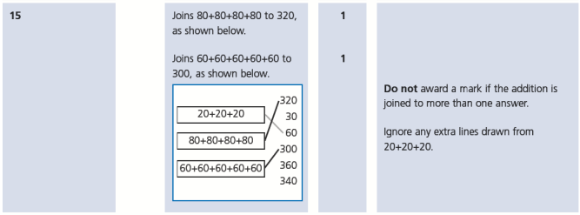
4.
KS1 – 2004 Paper 2
5.
6.
KS1 – 2005 Paper 1
7.
120

KS1 – 2005 Paper 2
8.
206

KS1 – 2007 Paper 2
9.
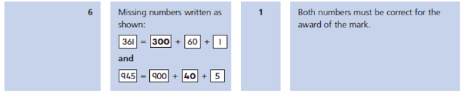
10.
KS1 – 2018 Paper – Arithmetic
11.

